int probe = A0;

void setup()

{

Serial.begin(9600);

pinMode(probe, INPUT);

}

void loop()

{

Serial.println( analogRead( probe ) );

}

**Multimeter analogRead( probe ); Scaled analogRead( probe);**

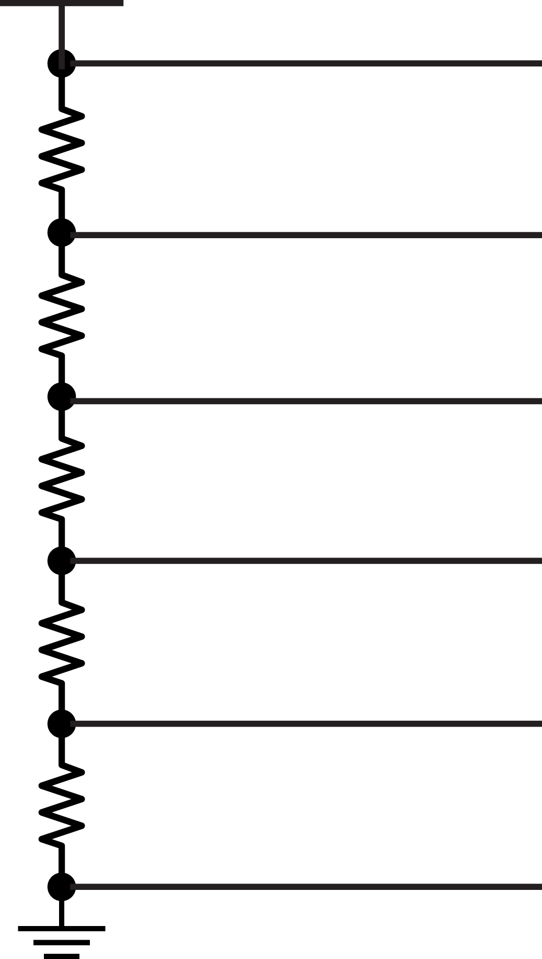  

**replace**

Serial.println( analogRead( probe ) );

**with**

Serial.println( 5 * ( analogRead( probe ) / 1024.0 ) );

**Analog in – Analog out**

#include <Servo.h>

Servo servo;

int probe = A0;

int min = 110;

int max = 570;

void setup()

{

Serial.begin( 9600 );

pinMode( probe, INPUT );

servo.attach( 9 ); //connect servo to pin 9

}

void loop()

{

Serial.println( analogRead( probe ) );

servo.write( map( analogRead( probe ), min, max, 0, 180 ) );

delay( 15 );

}

**Flex Circuit**

Minimum Value:___________________

Maximum Value:__________________

**CDS Circuit**

Minimum Value:___________________

Maximum Value:__________________

**Temperature Sensor**

int probe = A0;

double voltage = 0;

double celsius = 0;

double fahrenheit = 0;

void setup()

{

Serial.begin( 9600 );

pinMode( probe, INPUT );

}

void loop()

{

voltage = 5 * ( analogRead( probe ) / 1024.0 );

celsius = ( voltage -.5 ) * 100;

fahrenheit = celsius * ( 9 / 5.0 ) + 32;

Serial.println( fahrenheit );

}

